Matthew Oliver

Spring 2025  DES 335-A

Warring Worlds roleplaying game

# Important Information

#### Designer

Matthew Oliver

#### Instructor

Eric Cagle

#### President of DigiPen Institute of Technology

Claude Comair

#### Teaching Assistants

Caleb Starr-Criss

Alex Koo

Gabriel Hoefler

#### Links to Art Used

<https://www.google.com/url?sa=i&url=https%3A%2F%2Fthenobleartist.com%2Frogue-concept-art%2F&psig=AOvVaw2vtkegiZNyXcHc8MPYZf-I&ust=1740872762105000&source=images&cd=vfe&opi=89978449&ved=0CBEQjRxqFwoTCODIyN3G54sDFQAAAAAdAAAAABAQ>

<https://shorturl.at/e12Rm>

<https://shorturl.at/daNyn>

<https://shorturl.at/3qDhV>

<https://shorturl.at/7O6I8>

Contents

Important Information 1

Chapter 1: Introduction 6

How to Play 6

Materials Needed 6

The Two-Die System 6

[WORLD NAME] 7

Chapter 2: Lore 8

The World Children 8

The Humans 9

The World Spirit 9

Spirit Hubs 9

World Seeds 10

World Walkers 10

The Rift-World 11

Energies 11

Natural Energies 11

Rift-World Energies 11

The Adventurer’s Guild 11

Chapter 3: Factions 12

Human Factions 12

[NATION NAME] 12

[NATION NAME] 12

[NATION NAME] 12

World Children Factions 13

The Amphibian Tribe 13

The Cold-Blood Empire 13

The Confederated Ape Tribes 13

Neutral Factions 14

The Adventurer’s Guild 14

The Merchant’s Guild 14

The Craftsman’s Guild 14

Chapter 4: Making a Character 14

Step 1: Choose a Species 14

Step 2: Choose a Background 15

Step 3: Determine your Attributes 15

Step 4: Select your Starting Feats 16

Step 5: Starting Equipment 16

Leveling Up 16

Chapter 5: Species 17

Human 17

Wapiti (Elk Folk) 17

Ouaouron (Frog Men) 18

Mawa (Orangutan Men) 19

Iwana (Iguana Folk) 20

Chapter 6: Backgrounds 20

Blacksmith 20

Doctor 20

Hunter 21

Thief 21

Mental Magic Apprentice 22

Bonuses 22

Equipment 22

Town Guard 22

Bonuses 22

Equipment 22

Chapter 7: Goods and Services 23

Currency 23

Bartering 23

Buying 23

Selling 24

Equipment 24

Quality 24

Size 24

Armor and Shields 24

Weapons 25

Other Equipment 25

Goods 25

Monster Parts 25

Herbs 25

Materials 25

Valuables 25

Trade Goods 25

Chapter 8: Using Attributes and Skills 26

Attributes 26

Strength 26

Dexterity 26

Constitution 26

Intelligence 26

Acuity 26

Will 27

Utility Skills 27

Athletics 27

Brawn 27

Stealth 27

Acrobatics [UPDATE REQUIRED BECAUSE OF: MANEUVERING COMBAT SKILL] 27

Fine Control 27

Analysis 27

Critical Thinking 28

Research 28

Physical Perception 28

Social Perception 28

Social Skills 28

Physical Combat Skills 28

Aggression 28

Mobility 28

Defensiveness 28

Tactics 29

Ranged 29

Unarmed 29

Weapon Mastery 29

Magical Combat Skills 29

Mental Magic 29

Spiritual Magic 29

Physical Magic 29

Magical Defense 29

Ranged Magical Fighting 29

Melee Magical Fighting 29

Profession Skills 29

Using Skills 29

Advancing Skills 30

Chapter 9: Adventuring 31

Time 31

In Combat 31

Outside of Combat 31

Movement 31

Traveling 31

Types of Movement 31

Environment 32

Weather 32

Hazards 32

Light 32

Terrain 32

Temperature 32

Food and Drink 32

Social Interaction 33

Roleplay 33

Social Checks 33

Downtime 33

Using Professions 33

Resting 33

Chapter 10: Combat 35

Rounds 35

Turn Order 35

Turns 35

Action Points 35

Reaction Points 35

Actions 35

Offensive 35

Defensive 35

Movement 36

Other 36

Reactions 36

Offensive 36

Defensive 36

Other 36

Positioning 36

Difficult Terrain 36

Speeds 37

Space 37

Attacking and Defending 37

Making Attacks 37

Defending Against Attacks 37

Damage Types 37

Statuses 37

Harmful 37

Beneficial 38

Health 38

Hit Points 38

Damage 38

Wounds 38

Injury Score 38

Healing 39

Mounted Combat 39

Underwater Combat 39

Chapter 11: Spell Weaving 40

Mental 40

Tiers 40

Schools 40

Learning Mental Spells 41

Material Components 42

Casting Mental Spells 43

Spiritual 43

Appendix A: Equipment 0

Armor 0

Shields 0

Weapons 0

Shortbow 1

Longbow 1

Dagger 1

Shortsword 1

Greatsword 1

Other 2

Properties 2

General Properties 2

Armor Properties 2

Shield Properties 2

Weapon Properties 2

Appendix B: Feats 2

Utility Skills 2

Combat Skills 2

Profession Skills 2

Martial Skills 2

Magic Skills 2

Appendix C: Spells 2

Mental Magic 2

Abjuration 2

Conjuration 1

Divination 1

Enchantment 1

Evocation 1

Illusion 1

Restoration 1

Transmutation 1

Material Components 2

Appendix D: Enemies 2

Animals 2

Wolf 2

Monsters 2

Minor Green Slime 2

Humanoids 1

Human Bandit 1

World Walkers 1

Pine Cone Warrior 1

Behavioral Traits 1

Physical Traits 2

Appendix E: Characters 2

Character Sheet Downloads 2

Character Sheets 1

Appendix F: Credits 3

# Chapter 1: Introduction

## How to Play

### Materials Needed

To play Old World you will need at least 2 dice of each of the following types: d4, d6, d8, d10, and d12. You will also need a character sheet and pencil to make a character.

### The Two-Die System

How do you determine whether your attack hits the bandit or is evaded? What about whether you forge a legendary sword or a misshapen hunk of metal? Do you successfully seduce the dragon or do they turn you into a pile of ash? The answer to all of these questions is one roll away.

#### Step 1: What are you trying to accomplish?

The first step to making a check is figuring out what the check is for. Checks are made when trying to accomplish something where success is not guaranteed. For this example, we’ll be saying that we’re trying to sneak away from a guard.

#### Step 2: What skill and attribute does this use?

The next step is to determine what skill best fits what you’re trying to do. In our case this will most likely use the Stealth Skill as we’re trying to remain undetected. After figuring that out we look at what Attribute the Stealth Skill is tied to, which is Dexterity.

#### Step 3: What are we rolling

Now that we know what Skill and Attribute we’re using we can actually figure out what dice we’re rolling. Almost every check in Old World follows a 1dX + 1dY format. Where X and Y represent the number of sides on the die being rolled. To determine X and Y we look at the tier of the Skill and Attribute we’re using. Every Skill and Attribute in Old World has five tiers, with higher tiers representing a higher affinity in that field. Every tier is associated with one kind of die, starting from a d4 at tier 1 and going up to a d12 at tier 5. In this case lets say that our character is pretty Stealth and Dexterity focused, fitting a Roguish archetype. Our character will be tier 4 in Dexterity and tier 3 in Stealth, meaning that we roll a d10 and a d8.

#### Step 4: Determining the result

After figuring out which dice are being used you can go ahead and roll them. The sum of the two numbers rolled is called the result and is checked against some other value to determine success, with one exception. If the result of the die roll is lower than the sum of your Skill and Attribute tiers, then you can choose to use that value instead of the result. In our example we ended up rolling a 2 and a 1, giving us a result of 3. Because 3 is lower than the sum of our tiers, 4 and 3, we can instead choose to use that value to determine success. Thus, the result of our Stealth check is a 7.

#### Step 5: Success or Failure

After getting your result that value is compared against another to determine success or failure. This value can either be a DV (Difficulty Value) chosen by the DM, or it can be the result of a contesting check. If your result is higher than the value it’s being compared to, then the check was a success. If it is lower, then that’s a failure. In an uncontested check (against a DV) a tie is counted as a success. In a contested check ties are rerolled. In our case we’re sneaking away from a guard, meaning that we’re comparing our Stealth Check against their Physical Perception Check. Let’s say for our purposes the guard got a 4, meaning that our Stealth Check is successful and we’re able to sneak away from the guard.

#### Bonuses and Penalties

Sometimes you may receive a Bonus or a Penalty to a check. This represents any advantages or disadvantages that may affect that check. Every level of Bonus allows you to increase one of the dice being rolled by one step. Every level of Penalty forces you to decrease on of the dice being rolled by one step.

## [WORLD NAME]

[World Name] is a land of untamed nature. Vast biomes of all types stretch across the land, each one in Ecological Harmony. The World Children inhabit this land, existing in harmony with nature. It is said by the World Children that a World Spirit inhabits [WORLD NAME]. Ensuring that all lands stay in Ecological Harmony. This World Spirit acts through various means including the Spirit Hubs, Natural Energies, and World Seeds. [WORLD NAME] has existed in this way for generations, and throughout the land there was peace. Until the Rift opened and pieces of a different world came through.

Almost no one remembers the Rift, it exists well beyond the memories of most species. But some do remember. They say that there was no warning, one second everything was peaceful and then in the next, the sound came. A roar unlike any heard before or since, they say it sounded like [WORLD NAME] itself was bellowing in pain. This deafening sound echoed across the globe and when it was finished people began to look up, and saw it. They tell of a great tear, like a wound in the sky. On the other side of this tear there were what looked to be dark, swirling, purple clouds. Then these clouds started to pass through the Rift and quickly spread across the entire world. And then, as quickly as the Rift opened, it closed again, this time without a sound.

It didn’t take long for the purple clouds to dissipate and disappear. Peace seemed to return to [WORLD NAME], there was no great calamity or horrible disaster. Everything seemed to be normal. That was until the next batch of World Seeds arrived. All of a sudden the World Seeds started growing into strange, monstrous things. New things, which had never been seen before in [WORLD NAME]. For most this was nothing more than a strange occurrence. The monsters usually seemed to become confused and then flee. The oddest thing to come from the World Seeds was what seemed to be a new species of World Children. These people called themselves “Humans,” and at first seemed peaceful. Truly [WORLD NAME] remained in harmony.

That is until things starting going wrong. The new monsters that had been introduced began to throw the various ecosystems out of balance. Events that had never happened before started to become common. Food shortages, animal attacks, and even diseases assaulted the World Children. But the worst was yet to come. The Humans, upon seeing the World Children suffer at what they viewed to be normal occurrences, chose to betray the World Children that had previously been their friends. They began to attack the World Children, driving them out of their Native Lands. The Humans then claimed these lands for their own, establishing Nations and building settlements. But to the World Children, this was not their greatest sin. The most egregious act of all was the Human’s exploitation of the land. They would cut down forests, farm animals instead of hunting them, and, the most terrible of all, tear up the soil and destroy the plants to grow their own “crops.” By doing this the Humans destroyed the Land’s Ecological Harmony, and the World Spirit fled those lands, leaving them to the Humans.

The entire world has been thrown into chaos. Invasive Monsters stalk the land, killing people and animals alike. The Humans have slowly expanded, and now the various Nations each control multiple Lands. The World Spirit is suffering as more of its lands fall under the control of the Humans and thus out of its control. This continued for centuries, with the world changing more and more from its previous state.

And now, 500 years later, a strange balance has been found. The Human’s expansion has slowed, the ecosystems have mostly stabilized, with Monsters of course being a part of that, and a tense peace has been created between the World Children and the Humans. Trade has opened, people move freely, and a neutral entity has been formed: The Adventure’s Guild.

Now the world is yours to explore. Your DM will guide you through [WORLD NAME] as you embark on quests, go on journeys, and fight heroic battles. Will you find yourselves caught between two Warring Worlds or will you pick a side? What is the true nature of the World Spirit? What did the Rift do to [WORLD NAME]? Can a balance truly be found, or is this just the calm before another storm? All of this is up to you. Explore the world, learn the stories of various peoples, and try not to starve to death in Warring Worlds. Thank you for playing.

# Chapter 2: Lore

## The World Children

The World Children are the various intelligent Humanoid species that inhabit [WORLD NAME]. These species have lived in harmony for millennia, coexisting with each other and the Flora and Fauna of their Native Lands.

But now, many World Children have been driven from their Native Lands. These people exist as nomads and refugees. The World Children which have not been driven out face many dangers that they’re just now learning how to brave. Some World Children have become extremely territorial, some have embraced the refugees and now struggle even more, and some chose to emulate the Humans, forming Nations and vying for power.

However, all the World Children still worship the World Spirit. The differences between the various ideas and faiths have led to strife between some peoples, as they are unable to accept another version of the World Spirit. Others have chosen to unite their faiths, creating new beliefs that combine features of the old. And still, the World Spirit provides what it can.

The Humans tend to refer to the World Children as “Beast-Folk,” not as a derogatory term, but instead just as a reference to their similarity to various Animals.

## The Humans

The Humans are not native to [WORLD NAME]. Instead, they come from a distant land, across the ocean. The Humans landed on [WORLD NAME] centuries ago and founded their own Nations. It isn’t known why they came here, that knowledge has been lost to time, but in this land they have prospered. Their Nations have expanded, driving out the Beast-Folk who once made their homes there. But now, a new belief in peace and friendship has emerged in the Humans. They have started to trade with the Beast-Folk, and have opened their borders to travelers. They even founded the Adventurer’s Guild to exist as a neutral entity, a show of equality and friendship. Truly [WORLD NAME] has entered an era of peace and prosperity for all.

That is the Human version of their history on [WORLD NAME]. It is unknown why this is their belief when the Tear was a mere 500 years ago. But it seems that the Humans have forgotten their true past. Many of the World Children have forgotten it as well, since they are short-lived and the times were so chaotic, and so this Human version of events has become the standard told in this history books. Many World Children know that something else happened, that there was some great calamity generations ago, but many have attributed it to the Human’s landing and initial expansion.

Now the Humans exist all over [WORLD NAME], permeating the land in numbers never before reached by intelligent species. They have become as much a part of the world ecosystem as any other creature.

## The World Spirit

### Spirit Hubs

The World Children refer to places where the World Spirit focuses its energy as Spirit Hubs. Each of these Spirit Hubs is a nexus of Natural Energy, a place where World Walkers exist and tend to the needs of the ecosystems nearby. It is from Spirit Hubs that World Seeds are distributed, being given to the various World Children that live in the surrounding Lands.

Spirit Hubs usually take the form of a gigantic plant, one which would exist naturally in the Land that the Spirit Hub is in. Examples of this are giant trees, coral reefs, cacti, mushrooms, and flowers. Lands inhabited by these Hubs are called Spirit Lands, as they are the places where the World Spirit has the most power. The Ecological Harmony of these lands remains unaffected by the calamities that have struck [WORLD NAME], and they are a bastion for any World Children who have become displaced.

### World Seeds

World Seeds are small, unremarkable brown seeds which get distributed by the World Walkers to the World Children living near a Spirit Hub. When planted in soil the World Spirit is said to be able to coax the seed into growing. The world seed will then become either a plant or animal that is currently needed in that Land. Through this process, Lands connected to the World Spirit are able to attain Ecological Harmony.

However, now that Out-World Energies have mixed with the Natural Energies of [WORLD NAME], the World Spirit is forced to create strange things which would not normally be found in [WORLD NAME]. This includes the Monsters, which can now be found all over [WORLD NAME] as invasive species. Strangely, the World Seeds no longer become Humans, and so most people have forgotten that they even can or at one point did.

Though not nearly in the same quantity as before, the World Spirit still provides World Seeds to the various World Children around [WORLD NAME]. Unfortunately, the World Seeds are no longer viewed as positively as they once were. The World Children still give thanks for them, and they still help, but the threat of the seeds planted growing into Monsters has everyone on their toes. This is why the World Seeds have become a currency for the World Children, they are not immediately planted as they once were and instead are used to obtain things that might be needed more.

The Humans have no use for World Seeds as they will not grow into anything in soil not connected to the World Spirit. So the Lands that the Humans inhabit, which have had their Ecological Harmony destroyed, are not capable of being regulated at all. As such the Humans see the World Seeds as interesting but worthless, with only a few scholars seeing any value in them.

### World Walkers

The World Walkers are called “Plant-Folk,” by the Humans, this is because they are essentially Animal-like plants. The World Walkers can be found mostly in Lands which contain a Spirit Hub. Many World Children believe that this is because they have a stronger connection to the World Spirit there. The World Walkers are said to enact the World Spirits will, distributing the World Seeds which come from within Spirit Hubs and ensuring that Ecological Harmony is maintained.

Ever since the Tear, however, more aggressive and dangerous World Walkers have begun to spawn from the Spirit Hubs. These new World Walkers, called Spirit Guardians, act as defenders, ensuring that any attempts to destroy the Ecological Harmony of a Land is met with resistance.

The Spirit Guardians will act aggressively towards anyone who has acted to harm the Ecological Harmony of a Land. How they know who to attack and who not to is unknown, but some theorize that because the World Spirit inhabits them all, what one knows they all know. These Spirit Guardians are hostile to all Humans, except for those in the Adventurer’s Guild. One of the biggest reasons that the Adventurer’s Guild has so many recruits is that, for some unknown reason, Spirit Guardians will not attack Humans who join. It has been tested and if a Human harms the Ecological Harmony of a Land after joining then they will once again be treated with hostility by Spirit Guardians.

## The Rift-World

The Rift-World is the World Children’s name for the world from which all of the things which are not natural to [WORLD NAME] came from. No one knows what the Rift-World is, or why the Rift opened and brought things from another world in the first place.

## Energies

Energies are the World Children name for the strange forces which flow throughout the world. These energies are what the World Spirit uses in order to create things from the World Seeds and control the World Walkers.

Some theorize that the reason World Seeds can now turn into Monsters is because of Rift-World Energies. Originally there were only the Natural Energies, but when the Rift opened the energies from the Rift-World entered. Now [WORLD NAME] has energies from two worlds and the World Spirit has been forced to incorporate them into its processes of creation.

### Natural Energies

Natural Energies, also called Spiritual Energies, are the forces which have always existed in [WORLD NAME]. These are the forces of nature itself, the elements that are used to guide both creation and destruction. The eight energies known to the World Children are: Life, Death, Earth, Water, Air, Current, Heat, and Cold.

These energies are what guided [WORLD NAME] since its creation. They are what drove the World Spirit, and what allowed it to keep the world in Ecological Harmony.

These energies are also what the World Children use to perform magic. Magic using the Natural Energies is known as Spirit Magic.

### Rift-World Energies

Not much is known about the Rift-World Energies. Not many cultures have even theorized their existence. These energies supposedly came from the Rift-World when the Tear opened. Some believe that these energies are what cause the World Spirit to create Monsters from the World Seeds, as it acts using energies not of [WORLD NAME].

These energies are what the Humans use to perform their Mental Spellcasting. Unlike Natural Energies, the Rift-World energies don’t seem to come in specific types. The variety of effects that can be achieved using Mental Magic is so broad that categorizing the energies themselves is impossible.

## The Adventurer’s Guild

The Adventurer’s Guild was formed by the Human Nation of [NATION NAME] and quickly spread to the other Human Nations as well. The Adventurer’s Guild is the first institution to exist as a neutral party between the Humans and World Children. The formation of the Adventurer’s Guild is what began the slow process of reconciliation and friendship between the Humans and World Children.

# Chapter 3: Factions

## Human Factions

### [NATION NAME]

[NATION NAME] was founded in the Central Plains and quickly expanded to include the Old Growth Woods and Young Hills. [NATION NAME] stopped after this period of initial expansion and began to focus on industrialization. They were the first Human Nation to cause the destruction of the Ecological Harmony in their Lands and the World Spirit has ensured that Spirit Guardians patrol their borders to prevent future expansion.

The Capital of [NATION NAME] is called [CAPITAL NAME]. It is a sprawling city with great stone walls surrounding it. A center of commerce, [CAPITAL NAME] was the city in which the Adventurer’s Guild and later the Merchant’s Guild were founded. Now [CAPITAL NAME] exists as a testament to the possibility of peace between Humans and World Children, with peoples of all species wandering the streets.

### [NATION NAME]

[NATION NAME] was founded in the Forest of Titans and expanded slowly to include the central part of the World Spine. [NATION NAME] is built, literally, on the wood of the massive trees which have stood for eons in the Forest of Titans. Each tree felled produces enough lumber to build an entire town, and so [NATION NAME] chose to focus on building large.

[NATION NAME] may not control much territory, but it is the undisputed world king of industry and crafting. The sheer amount of lumber that it is able to produce allows for a massive mining operation in the World Spine. Raw materials are refined and distributed to be used in construction, crafting, and any number of other processes. [NATION NAME] is also where the Craftsman’s Guild was founded, to encourage the use of Materials.

### [NATION NAME]

[NATION NAME] was founded in the Sea of Sand and was one of only two Human Nations that cooperated with the World Children. The Sea of Sand proved to be an inhospitable and dangerous place. None can deny that the Human’s ability to adapt is nothing short of miraculous, but the desert proved to be too much for them. The Humans of [NATION NAME] understood that they had no chance of survival on their own. So they chose to listen and heed the words of the World Children.

[NATION NAME] is the only remaining Human Nation which uses World Seeds. The use of World Seeds is carefully controlled to ensure that enough food is available for everyone. Any food deficits are covered through trade with nearby Humans and World Children.

## World Children Factions

### The Amphibian Tribe

The Amphibian Tribe lives in the Eastern Swamp and took in several of the refugee species displaced by [HUMAN NATION]. The Amphibian Tribe consists of the Ouaouron, the [AMPHIUMA PEOPLE], and the [SNAPPING TURTLE PEOPLE]. This tribe is generally friendly to outsiders, and all three species can be commonly seen in the Guilds.

The Amphibian Tribe was left alone by [HUMAN NATION] as it seems that they had no use for the swampy biomes that the Amphibians call home. As such the Amphibians have continued to live as normal, with the exception of new homes being built for the refugee species.

### The Cold-Blood Empire

The Cold-Blood Empire is found in the Jungle of the Sun. The Empire is made up of several Cold-Blooded species, namely the Iwana, [ANACONDA PEOPLE], [POISON DART FROG PEOPLE], and the [CAIMIN PEOPLE]. Before the rift, these species existed as separate tribes which would roam the rainforest in search of food. They all shared a similar view of the World Spirit, that of a great snake.

When the Rift came the Cold-Bloods were left fairly untouched. Life in the jungle had always been difficult, and a few new monsters to worry about didn’t change much. That was until the [ANACONDA PEOPLE] came across a Red Dragon Hatchling.

The [ANACONDA PEOPLE] were amazed and enraptured by this snake which could speak their language. They were even more amazed when that snake grew at an alarming rate. The [ANACONDA PEOPLE] saw this as an omen. The Avatars of the World Spirit had come, and the [ANACONDA PEOPLE] would do their bidding.

Word quickly spread to the other Cold-Bloods living in the area and they joined in this new-found purpose. Their new Avatar demanded food, and so food they brought. Over the next few centuries, the Empire would practice a daily ritual of sacrifice to the Avatar, which continued to grow until it became gargantuan. The Empire raids surrounding Lands, kidnapping any intelligent peoples they find to be forced into slavery and eventual sacrifice. Some say that the Empire is looking to expand its territory and may soon send out an army to take over nearby Lands.

### The Confederated Ape Tribes

The Confederated Ape Tribes live in the Home Jungle. This group is made up of the Mawa, [CHIMPANZEE PEOPLE, and the [GORILLA PEOPLE]. These species historically existed as separate tribes which would war for territory. That is until about 400 years ago when they united, forming a new Nation.

The Confederated Ape Tribes are friendly but territorial. They engage in trade with the nearby World Children and Humans but permit few visitors. All three species of the Ape Tribes are naturally curious, and many have made their way out into the wider world as travelers.

## Neutral Factions

### The Adventurer’s Guild

The first of the Guilds, created by [HUMAN NATION] to encourage friendship between Humans and World Children. The Adventurer’s Guild now has locations all over [WORLD NAME] and there is at least one member of almost every species. Leaders in the Adventurer’s Guild are chosen based on merit, with anyone of a high enough Rank being considered.

Members of the Adventurer’s Guild are allowed to take Quests, which are tasks that typically have a reward upon completion. These Quests can be posted by anyone, businesses, governments, individuals, or even the Guild itself. Quests can consist of almost anything, but the general outline can be found in the [QUESTS SECTION] of the Adventuring Chapter.

Member of the Adventurer’s Guild are categorized into Ranks, with each successive Rank representing a higher level of skill and experience. These Ranks, from lowest to highest, are: Hatchling, Fledgling, Strider, Hunter, and Elder. Adventurers are typically only allowed to take Quests with a difficulty estimated to be at their Rank or lower.

### The Merchant’s Guild

The Merchant’s Guild was the next Guild to be formed. With the newfound friendship and trade between Humans and World Children, opportunities for profit were everywhere. A position as a Leader in the Merchant’s Guild is bought, with the price changing only in relation to the economy.

Members of the Merchant’s Guild are allowed to take Deals. These typically represent a request for the transport, delivery, or sale of certain Goods.

### The Craftsman’s Guild

The Craftsman’s Guild is the newest of the Guilds. Now that adventuring and trade have become more common, someone needed to be able to craft and repair equipment. A position as a Leader in the Craftsman’s Guild is given to anyone who has crafted a Legendary item.

Members of the Craftsman’s Guild are allowed to take Orders. An Order represents a request for a craftsman to either make or repair equipment. There are generally two types of Orders: Materials Provided, and Materials Not Provided.

# Chapter 4: Making a Character

The following rules will teach you how to make a level 1 character in Warring Worlds. To further explain these rules we will show you how to make Duggory. A level 1 character focused on healing and aiding his team using mental magic.

## Step 1: Choose a Species

The creation of every adventurer starts by choosing a species. The world of [WORLD NAME] contains a wide variety of intelligent species. Will you choose to be one of the Amphibian Folk? Or maybe one of the Ape Men? Various species can be found almost anywhere in the world of [WORLD NAME] and any background is available to any species, so feel free to choose whichever one looks like the most fun to you.

Your species affects several aspects of your character, including a bonus to one of your attributes, your starting language(s), your size, your base movement speed(s), and can include some other traits.

You can choose a species that suits the character you want to make or just go wild. Just because Ouaouran get a bonus to Dexterity doesn’t mean that you have to play a Dexterity based character. Be a Frog Wizard! Or maybe an Elk Assassin? The possibilities are endless!

The first step to making Duggory is choosing his species. In this case I’ll go with Mawa as they get a boost to Intelligence, the main Attribute used for mental magics.

## Step 2: Choose a Background

Who were you before you became an adventurer? Were you a blacksmith? Maybe a thief? Your background can give you one or several bonuses to start with, giving you a head start on the road to building the adventurer you want.

Most backgrounds will let you start as a Novice in one of the Profession Skills and may give bonuses to other Skills as well. Your background will also give you a couple pieces of starting equipment, easing your initial spending.

The next step for Duggory is choosing a background. I’ll go with Mental Magic Apprentice as that lets him start at Tier 2 in Mental Magic and gives him a spellbook with some spells already in it.

## Step 3: Determine your Attributes

All beings in [WORLD NAME] have six basic attributes. These are Strength, Dexterity, Constitution, Intelligence, Acuity, and Will. These attributes represent a being’s various physical and mental abilities.

At Level 1 all adventurers start with the same basic spread of stats. You get 5 Attribute Points to allocate. Increasing an Attribute costs a number of points equal to its current Tier. For example, increasing an Attribute from Tier 1 to Tier 2 costs 1 point, but going from Tier 2 to Tier 3 costs 2 points.

After choosing your attributes you can also fill in your max health and max wounds. At level 1 your max health is always equal to the sum of the maximum for your Constitution and Will dice. Your max wounds is equal to your Constitution Tier plus your Will Tier.

It is recommended that you choose your attribute spread based on the kind of character you want to be. Are you going to be a sword-wielding knight? Strength and Constitution are your friends. Want to be a spell-slinging mage? Intelligence and Will are what you need. Choose an attribute spread that best fits the play style you’re going for.

When choosing what to put Duggory’s points into I am considering two things. First, Duggory uses mental magic, so Intelligence is his most important attribute. Second, it’s always a good idea to increase your defenses, even as a magic user. So I’ll spend my first two points increasing Intelligence to Tier 3, remember that it was already at Tier 2 because Duggory is a Mawa. Then I’ll spend my remaining points to increase Will, Dexterity, and Constitution to Tier 2. This gives Duggory good defensive options. Diggory’s max health will be 12 as both his Constitution and Will are Tier 2, which means they are a d6. Duggory’s max wounds will be 4.

## Step 4: Select your Starting Feats

At level one every adventurer starts with the following: 3 Utility Points and 3 Combat Points. These points work similarly to the Attribute Points in Step 3. The difference is that Utility Points can only be used on Utility Skills and Combat Points can only be used on Physical or Magical Combat Skills.

Your feats are what determines your adventurer’s playstyle so make sure to choose them based on who you want to play. Also make sure to choose them based on what feats you’ll have access to as you go down those trees, you might find that while one feat fits your playstyle better now, there might be feats in another section of the tree that will fit your character better.

First lets do Duggory’s Utility Points. I’m going to put them into Acrobatics, Critical Thinking, and Research. This allows Duggory to have some interesting movement options and will help him find and learn new spells. I’ll then spend my Combat Points on Mental Magic and Defensiveness, which uses all 3 because Mental Magic was already at Tier 2.

## Step 5: Starting Equipment

At level 1 every adventurer starts with a set amount of currency. The type of currency they start with is determined by their species. Human adventurers start with 10 Pings and World Children adventurers start with 25 World Seeds. You are then given the opportunity to pre-purchase any equipment you want before the start of the campaign.

For Duggory the main thing would be to make sure he has a spellbook, but since he already has one that money can instead be saved. Duggory doesn’t particularly need any equipment so he’ll just have his spellbook.

## Leveling Up

# Chapter 5: Species

## Human

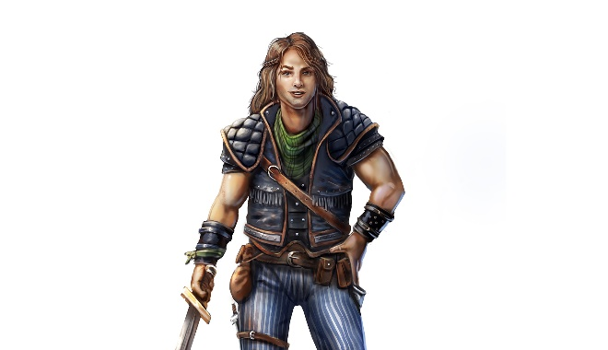

Bonuses

Humans are an extremely varied race, coming in all shapes and sizes. Choose one Attribute to increase by a tier.

Languages

[COMMON LANGUAGE], Outworld

Aging

Humans reach maturity at around the age of 20 and live until around 80.

Size

Humans are medium creatures.

Movement

Humans have a base walking speed of 45ft.

Appearance

Culture

History

Other Traits

## Wapiti (Elk Folk)

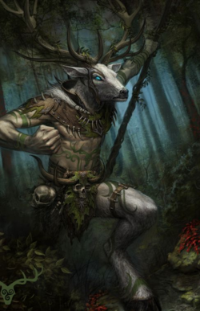

Bonuses

Wapiti are naturally strong, increase your strength attribute by one tier.

Languages

[COMMON LANGUAGE], [SYLVAN LANGUAGE]

Aging

Wapiti reach maturity at the age of five and live about forty years.

Size

Wapiti are medium creatures.

Movement

Wapiti have a base walking speed of 60ft.

Appearance

Culture

History

Other Traits

All Wapiti possess horns, which start growing once they reach maturity. These horns count as a natural weapon and can be found in [NATURAL WEAPONS APPENDIX]

## Ouaouron (Frog Men)

Wad-ah-rohn

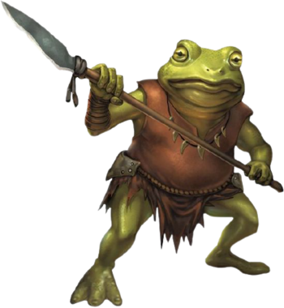

Bonuses

Ouaouron are naturally mobile, increase your dexterity attribute by one tier.

Languages

[COMMON LANGUAGE], [AMPHIB LANGUAGE]

Aging

Ouaouron are born as tadpoles, which gradually grow into adults, reaching maturity at the age of two. Ouaouron live until about twenty.

Size

Ouaouron are medium creatures.

Movement

Ouaouron have base walking and swimming speeds of 30ft.

Appearance

Culture

History

Other Traits

Ouaouron are natural jumpers and universally have the **Leap** ability, found in the [ABILITIES APPENDIX]

Ouaouron have a long, sticky tongue, which counts as a natural weapon, found in the [NATURAL WEAPONS APPENDIX]

## Mawa (Orangutan Men)

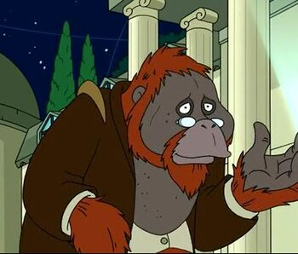

Bonuses

Mawa are naturally intelligent, increase your intelligence attribute by one tier.

Languages

[COMMON LANGUAGE], [APE LANGUAGE]

Aging

Mawa reach maturity at the age of 15 and live until around 60

Size

Mawa are medium creatures.

Movement

Mawa have base walking and climbing speeds of 30ft.

Appearance

Culture

History

Other Traits

## Iwana (Iguana Folk)

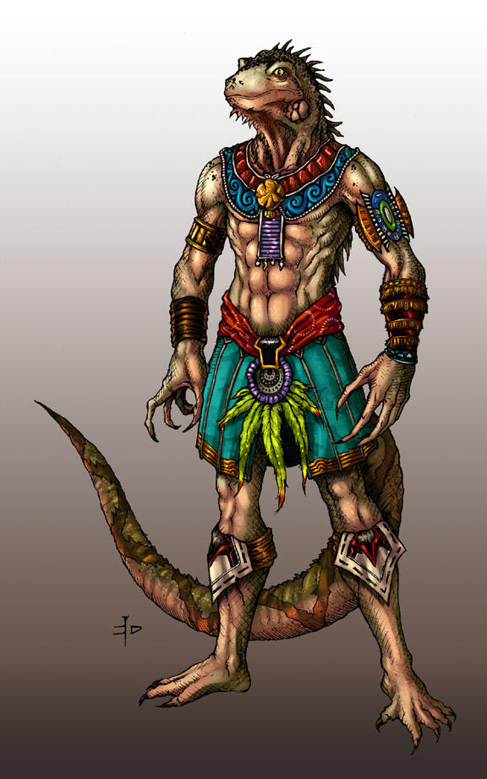

Bonuses

Iwana are naturally dexterous, increase your dexterity attribute by one tier

Languages

[COMMON LANGUAGE], [SOUTH AMERICA REPTILE LANGUAGE]

Aging

Iwana reach maturity at the age of 5 and live to around 30

Size

Mawa are medium creatures.

Movement

Mawa have base walking and swimming speeds of 30ft.

Appearance

Culture

History

Other Traits

# Chapter 6: Backgrounds

## Blacksmith

Bonuses

Adventurers who have a background in smithing start as a Novice in the Smithing Profession Skill

Equipment

You start with Smithing Tools and a Low-Quality item of your choice, which you forged.

Description

## Doctor

Bonuses

Adventurers who have a background as a doctor starting as a Novice in the Physician Profession Skill

Equipment

You start with a Medical Kit

Description

## Hunter

Bonuses

Adventurers who have a background as a doctor starting as a Novice in the Hunting Profession Skill

Equipment

You start with a Survival Kit and a Low Quality Long Bow

Description

## Thief

Bonuses

Adventurers who have a background as a thief starting as a Novice in the Stealth Utility Skill

Equipment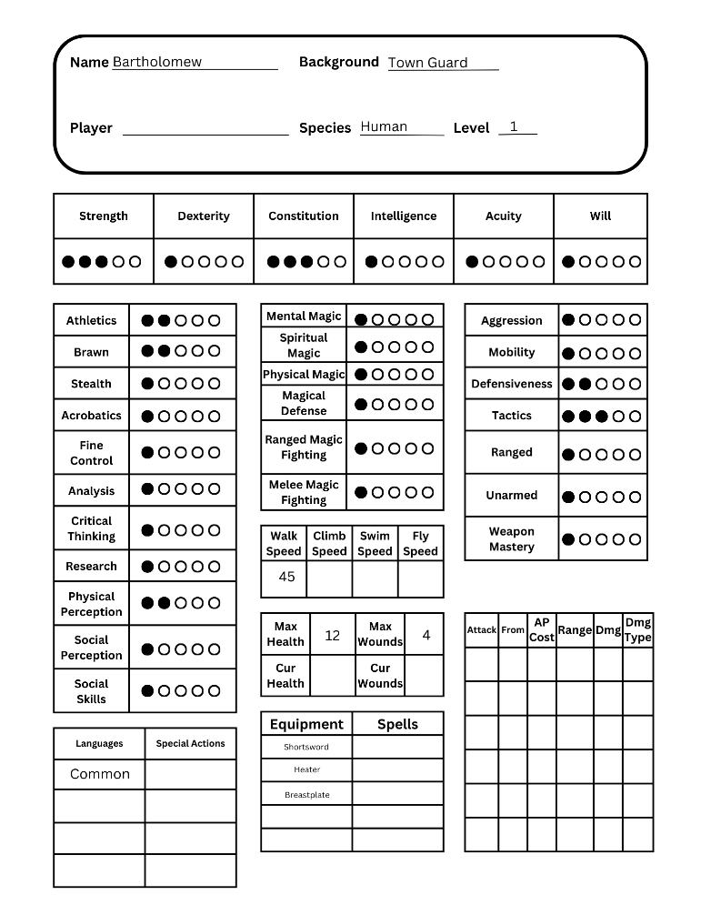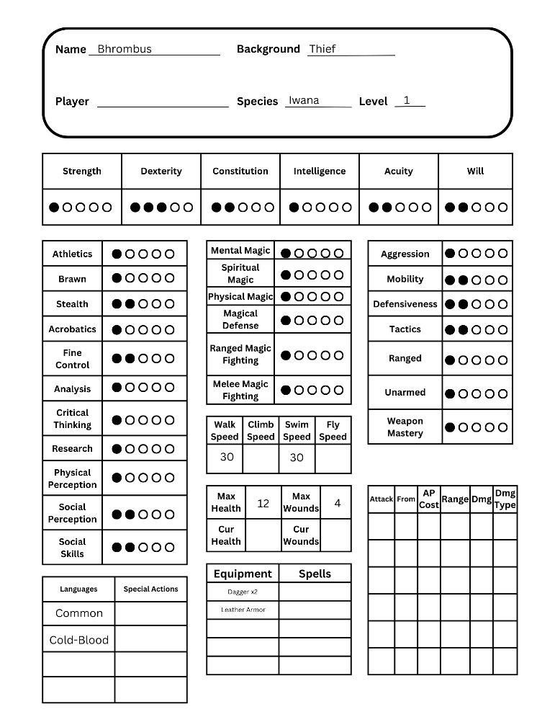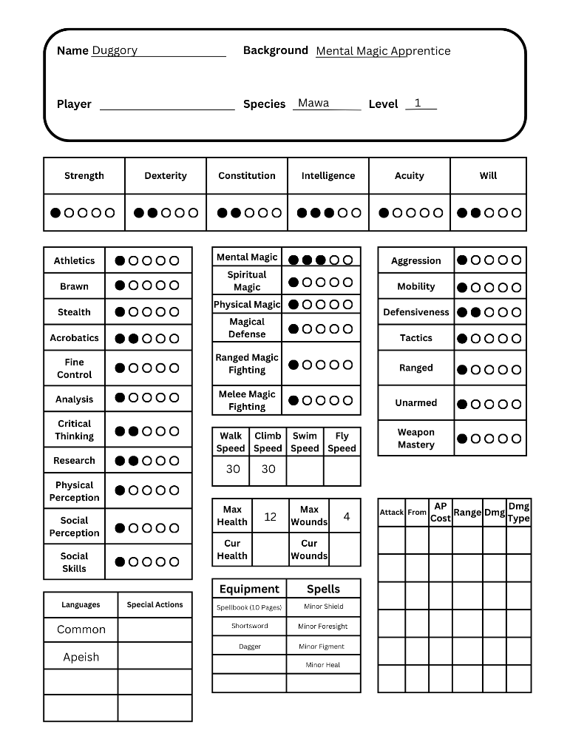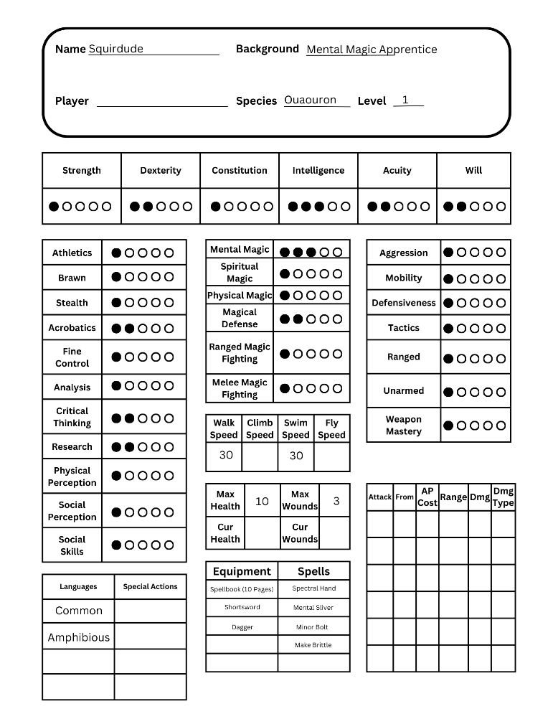

You start with two daggers and 10 extra gold

Description

## Mental Magic Apprentice

### Bonuses

Start as a Disciple in Mental Magic

### Equipment

Start with a Spell Book which has 10 pages and contains 4 Seeker-Tier spells of your choosing, you have Memorized these spells.

## Town Guard

### Bonuses

Start as a Novice in a Physical Combat Skill of your choice

### Equipment

Start with one weapon of any type and one piece of armor of any type.

# Chapter 7: Goods and Services

## Currency

Currency in the world of [WORLD NAME] comes in two main forms. The Human kingdom of [HUMAN KINGDOM NAME] uses coins made of Gold, Silver, and Copper, with 100 Copper equaling 1 Silver, and 100 Silver equaling 1 Gold. The Native Tribes and Empires all use World Seeds as currency.

The Humans use what they view as “Precious Minerals,” to make their currency. They mine up the raw, untapped ores of [WORLD NAME], transport them, process them, and turn them into coins. These coins can then be used to purchase goods and services. The entire Human economy runs off these minerals, and they always want more. After they’ve been turned into coins the Humans name them. The gold coins are called “Landings,” the silver are “Foundings,” and the copper are “Prosperings.” Those are the official names, but most people call them “Lings,” “Fings,” and “Pings,” for gold, silver, and copper respectively.

The Natives have a very different system of “economy.” The Natives use an item called a “World Seed,” which like coins can be exchanged for goods and services. That, however, is the only similarity. First, World Seeds don’t come from mining. Instead, World Seeds are occasionally given out to the various Native Species by the People of the World. These People of the World live in the World Forests sprinkled around [WORLD NAME], and bring the World Seeds to the various peoples. That is the extent of the Human’s knowledge of the process, and it is true the no one knows where the World Seeds come from or how they are made. But, what the Humans don’t know is that the World Seeds actually have a use, unlike their coins. When a World Seed is planted, it grows into whatever plant *or* animal that the environment it’s in is currently lacking.

## Bartering

### Buying

Goods and Services in [World Name] tend to have two prices associated with them. The first is the Human Price, or what you should expect to pay in a Human settlement. The second is the Native Price, or what you should expect to pay in any Native settlement.

The different currencies are generally not exchangeable, Natives will not allow Humans to have World Seeds and have no use for coins. So, trading between Humans and Natives is generally only done through useable goods, things like food or materials. This means that any Human adventurers will never be given World Seeds in payment, it will always be something else. The only exception is Humans who are completely trusted, which is exceedingly rare.

The prices listed on all entries are the default, but can be brought down through use of the Persuasion Utility Skill. Prices listed as “HC,” are the cost in Human Currency, and prices listed as “NC,” are the cost in Native Currency.

### Selling

When selling goods it’s important to remember that the price you will get is dependent on how much the buyer wants or needs that good. If you’re trying to sell gear to a town with several blacksmiths, then you’re not going to get a good price. That said different kinds of goods will have different markdowns so in general here’s what you should expect:

#### Armor, Weapons, and Other Equipment

Typically, undamaged Armor, Weapons, or Other Equipment will sell for about 70% of the listed price.

#### Monster Parts

Monster Parts are very dependent on the rarity of the monster and who you’re selling to, but you can expect to get around 60-80% of the listed price.

#### Herbs

Useful Herbs are very dependent on the availability of that Herb, but typically sell for 70-90% of the listed price.

#### Materials

Materials are usually bought in bulk, which means the cut is much better, usually around 90% of the listed price.

#### Valuables

Valuables tend to sell for a lot, but also have a very high markup. Around 40% of the listed price is common.

#### Trade Goods

Trade Goods are unique in that they are commonly used directly for bartering, including bartering between Humans and Natives. Because of this Trade Goods are usually worth 100% of the listed price.

## Equipment

BECAUSE OF SIZE LIMITATIONS, ALL ITEM TABLES CAN BE FOUND IN [EQUIPMENT APPENDIX]

### Quality

### Size

### Armor and Shields

Armor falls into five categories: Very Light, Light, Medium, Heavy, and Very Heavy. Wearing Armor provides a passive reduction to all damage of the Damage Type(s) covered by that Armor. Some Armor will also have other bonuses or penalties, so it’s important to choose armor that fits your playstyle.

Shields provide a bonus to your ability to block attacks, and sometimes have attacks of their own. Shields come in three categories: Small, Medium, and Large, each category up increases the bonus to blocking, but also introduces new penalties.

#### Armor

|  |  |  |  |  |  |  |  |
| --- | --- | --- | --- | --- | --- | --- | --- |
| Name | Category | HC | NC | Weight | Quality | General Properties | Armor Properties |
|  |  |  |  |  |  |  |  |
|  |  |  |  |  |  |  |  |
|  |  |  |  |  |  |  |  |
|  |  |  |  |  |  |  |  |
|  |  |  |  |  |  |  |  |

### Weapons

Weapons fall into two categories: Melee and Ranged, with some weapons technically falling into both. All weapons have associated Attacks, which can be used while the weapon is being wielded. Weapons also have their own associated Weapon Skill, which is unique per weapon. Weapon skills can have a variety of associated feats, from increasing the damage of attacks to unlocking new abilities. These Weapon Skills can be found in [FEAT APPENDIX]

### Other Equipment

There are plenty of items that can help you on your journey. Whether it’s rope or ball bearings, someone is going to find it useful, equipment comes in all shapes and sizes, but generally falls into the following categories:

#### Ammunition

All ranged weapons take some form of ammunition. Ammunition is typically sold, and priced, in terms of bundles. The amount of ammunition in a bundle is dependent on the ammo, but generally it’s 20 pieces per bundle.

#### Gear

Gear includes a wide variety of things but be summarized as any useful item someone can carry. This includes things like rope, which has a variety of uses. Handcuffs also fall under Gear, but who knows what you’ll end up using those for?

#### Tools

Tools and Tool Kits are used to perform Profession Checks. For example, you can’t attempt to smith something unless you have access to all the necessary Smithing Tools.

#### Kits

Kits are unique in that they’re just a variety of useful items all packaged together in a convenient little bundle. An Adventuring Kit for example contains generally useful things like a Backpack, Rope, Flint and Steel, and some other goodies.

#### Containers

Not everyone can carry 50lbs worth of gear in their pockets, most people are going to put it in a container of some kind. Containers have a set amount of weight that they can hold and always count as weighing this much when carried. However, anything that is put inside a container does not add its weight to a character’s Encumbrance.

## Goods

### Monster Parts

### Herbs

### Materials

### Valuables

### Trade Goods

# Chapter 8: Using Attributes and Skills

All Attributes and Skills have five ranks, representing a character’s aptitude with that Attribute or Skill. These ranks range from 1 to 5, with 1 representing the lowest level of ability and 5 the highest.

## Attributes

Attributes fall into two types, Physical and Mental. Attributes also have five ranks, similar to Skills. These ranks indicate a character’s ability in that Attribute.

The first type is the Physical type, this includes Strength, Dexterity, and Constitution. These three Attributes affect a character’s physical stats.

The second type is the Mental type, this includes Intelligence, Acuity, and Will. These three Attributes affect a character’s mental stats.

### Strength

Strength represents a character’s physical might. How good is someone at lifting things? Hitting things? Carrying things? All of these are determined by a character’s Strength. Strength affects: Accuracy and Damage with some Melee, Strength-based Skills, Blocking, and a character’s Carrying Capacity. The five Strength ranks are: Atrophied, Weak, Fit, Strong, and Herculean.

### Dexterity

Dexterity represents a character’s physical mobility. How good is someone at dodging things? Performing Acrobatics? Being sneaky? All of these are determined by a character’s Dexterity. Dexterity affects: Accuracy and Damage with Ranged and some Melee, Evasion, and Dexterity-based Skills. The five Dexterity ranks are: Clumsy, Uncoordinated, Nimble, Graceful, and Cat-like.

### Constitution

Constitution represents a character’s physical toughness. How good is someone at taking hits? Resisting Poison and Disease? Healing? All of these are determined by a character’s Constitution. Constitution affects: Health and Injury Tolerance, resistance to Poison and Disease, and Natural Healing. The five Constitution ranks are: Sickly, Delicate, Healthy, Robust, and Impervious.

### Intelligence

Intelligence represents a character’s mental prowess. How knowledgeable is someone? How easily do they learn new things? How good are they at problem solving? All of these are determined by a character’s Intelligence. Intelligence affects: Accuracy and Damage with Arcane Magic and Intelligence-based Skills. The five Intelligence ranks are: Slow, Dumb, Competent, Bright, and Genius.

### Acuity

Acuity represents a character’s mental sharpness. How witty is someone? How good are they in social scenarios? How perceptive are they? All of these are determined by a character’s Acuity. Acuity affects: Attack and Damage with Spiritual Magic and Acuity-based Skills. The five Acuity ranks are: Dull, Absent-Minded, Sharp, Keen, and Witty.

### Will

Will represents a character’s mental toughness. How resilient is someone? How strong is their mental fortress? How well do healing spells work on them? All of these are determined by a character’s Will. Will affects: Resistance to Mental Attacks and how well Healing Spells work on them. The five Will ranks are: Spineless, Cowardly, Determined, Stalwart, and Unbreakable.

## Utility Skills

Utility Skills are used to represent a character’s ability in specific situations. For example, a character’s ability to swim is not useful all the time, but there could be a scenario in which being good at swimming is useful. All Utility Skills have associated Feat Trees, which represent a character’s general ability with that skill, and their ability in the various subcategories of that skill. Utility Skill Feat Trees can be found in [FEAT APPENDIX].

### Athletics

Athletics is a Strength-Based skill. Athletics represents a character’s ability to do Strength-Based movement. The subcategories of Athletics and examples of things you might make Athletics checks for are: Running, Jumping, Swimming, and Climbing.

### Brawn

Brawn is a Strength-Based skill. Brawn represents a character’s ability to do Strength-Based actions. The subcategories of Brawn and examples of things you might make Brawn checks for are: Lifting, Carrying, Throwing, and Smashing.

### Stealth

Stealth is a Dexterity-Based skill. Stealth represents a character’s ability to avoid detection. The subcategories of Stealth and examples of things you might make Stealth checks for are: Sneaking, Disguising, Trailing, and Distracting.

### Acrobatics [UPDATE REQUIRED BECAUSE OF: MANEUVERING COMBAT SKILL]

Acrobatics is a Dexterity-Based skill. Acrobatics represents a character’s ability to do Dexterity-Based movement. The subcategories of Acrobatics and examples of things you might make Acrobatics checks for are: Tumbling, Vaulting, Balancing, and Weaving.

### Fine Control

Fine Control is a Dexterity-Based skill.   
Fine Control represents a character’s ability to perform actions requiring fine motor skills. The subcategories of Fine Control and examples of things you might make Fine Control checks for are: Catching, Manipulating, Grabbing, and Artistry.

### Analysis

Analysis is an Intelligence-Based skill. Analysis represents a character’s ability to reason or understand. The subcategories of Analysis and examples of things you might make Analysis checks for are: Identifying, Examining, Understanding, and Recognizing.

### Critical Thinking

Critical Thinking is an Intelligence-Based skill. Critical Thinking represents a character’s ability to reason or deduce. The subcategories of Critical Thinking and examples of things you might make Critical Thinking checks for are: Reasoning, Problem Solving, Strategizing, and Evaluating.

### Research

Research is an Intelligence-Based skill. Research represents a character’s ability to find information, and learn about, a topic. The subcategories of Research and examples of things you might make Research checks for are: Investigation, Interpretation, Compilation, and Sourcing.

### Physical Perception

Physical Perception is an Acuity-Based skill. Physical Perception represents a character’s ability to notice things around them. The subcategories of Physical Perception and examples of things you might make Physical Perception checks for are: Spotting, Smelling, Hearing, and Tasting.

### Social Perception

Social Perception is an Acuity-Based skill. Social Perception represents a character’s ability to notice things about people around them. The subcategories of Social Perception and examples of things you might make Social Perception checks for are: Honesty, Emotions, Intentions, and Influence.

### Social Skills

Social Skills is an Acuity-Based skill. Social Skills represents a character’s ability to interact with other people. The subcategories of Social Skills and examples of things you might make Social Skills checks for are: Deception, Persuasion, Intimidation, and Performance

## Physical Combat Skills

Combat Skills are used to represent a character’s abilities in a combat situation. For example, the Defensive Fighting Skill is used for Blocking, Evasion, and Zone of Influence. Like Utility Skills, Combat Skills all have associated Feat Trees, found in the [FEAT APPENDIX]

### Aggression

The Aggressive Fighting Skill covers offensive styles of melee combat. Masters of this skill use overwhelming force to crush or cleave their foes. The subcategories of Aggressive Fighting and examples of things you can use Aggressive Fighting for are: Power, Recklessness, Relentlessness.

### Mobility

The Combat Mobility Skill covers physical movement and speed during combat. Masters of this skill are all over the battlefield, literally running circles around their enemies.. The subcategories of Combat Mobility and examples of things you can use Combat Mobility for are: Initiative, Footwork, and Mounting.

### Defensiveness

The Defensive Fighting Skill covers defensive styles of melee combat. Masters of this skill are immovable objects, blocking or evading every attack that comes their way. The subcategories of Defensive Fighting and examples of things you can use Defensive Fighting for are: Blocking, Evading, and Zone of Control

### Tactics

The Measured Fighting Skill covers precise and tactical styles of melee combat. Masters of this skill control the battlefield, acting as conductors directing the flow of combat. The subcategories of Measured Fighting and examples of things you can use Measured Fighting for are: Precision, Flow, and Balance.

### Ranged

The Ranged Fighting Skill covers ranged styles of combat. Masters of this skill attack their foes from afar, dealing death from a distance. The subcategories of Ranged Fighting and examples of things you can use Ranged Fighting for are: Sniping, Trick Shots, and Throwing.

### Unarmed

The Unarmed Fighting Skill covers unarmed styles of melee combat. Masters of this skill use only what they were born with, subjugating enemies without the aid of weapons. The subcategories of Unarmed Fighting and examples of things you can use Unarmed Fighting for are: Striking, Grappling, and Natural Weapons.

### Weapon Mastery

The Weapon Mastery Skill covers aptitude with various weapons. Masters of this skill know how to use their chosen weapon to its full potential, unleashing techniques that best utilize their weapon’s strengths. The subcategories of Weapon Mastery and examples of things you can use Weapon Mastery for are: One-Handed Weapons, Two-Handed Weapons, and Ranged Weapons.

## Magical Combat Skills

### Mental Magic

The Mental Magic Skill represents a character’s aptitude with Mental Magic. Masters of this skill are usually Lore Keepers in at least 1 or 2 Schools. Mental Magic is split into 8 Schools, with every School representing a different category of spells.

### Spiritual Magic

Coming in V0.3

### Physical Magic

Coming in V0.4

### Magical Defense

The Magical Defense Skill covers defense against Magical Attacks. Masters of this skill have an indomitable mind and spirit and are unphased by any assault made against them. The subcategories of Magical Defense and examples of things you can use Magical Defense for are: Mental Defense, Spiritual Defense, and Energy Defense.

### Ranged Magical Fighting

The Ranged Magical Fighting Skill covers the use of ranged spells. Masters of this skill cast bolts with perfect accuracy and can aid their allies from great distances. The subcategories of Ranged Magical Fighting and examples of things you can use Ranged Magical Fighting for are: Casting Bolts, Throwing Lobbers, Creating Areas, and Focusing.

### Melee Magical Fighting

The Melee Magical Fighting Skill covers the use of melee spells. Masters of this skill combine spell weaving with melee combat, hammering foes with magical blows. The subcategories of Melee Magical Fighting and examples of things you can use Melee Magical Fighting for are: Worming Past Defenses,

## Profession Skills

Coming in V0.3

## Using Skills

## Advancing Skills

[SKILL ADVANCEMENT IS UNDER WORKS, I HAVE SEVERAL POSSIBLE SYSTEMS IN MIND]

Get different kinds of XP when performing different actions and spending that to gain new feats

Milestone leveling where you get to select a set number of new feats every level

Getting different kinds of points after every session depending on what you did that session and spending them to gain new feats

# Chapter 9: Adventuring

## Time

### In Combat

Time in Combat is kept very simple. While in combat, every Round represents 10 seconds. That means that no matter how many turns are taken, or how many actions performed, the span between the beginning and end of a Round is always exactly 10 seconds. This can be used for the purposes of duration, if a spell lasts for 60 seconds, that means that it lasts for 6 Rounds.

### Outside of Combat

Time outside of Combat is trickier. Typically, the passage of time is left up to the DM, it is up to them how long things will take. The time something takes is dependent on the action being performed. For example, bartering with a shopkeeper might take a few minutes. Searching a city for a particular person might take hours. And traveling between two settlements might take days. It is up to the DM to decide how long things take.

## Movement

### Traveling

When traveling long distances the speed of the party is very important, sometimes it matters whether you get to a town tonight or tomorrow morning. A chart can be found in [HELPFUL APPENDIX] which gives various speeds, distances, and times for various methods of travel.

### Types of Movement

All types of movement are represented using distance in feet. This distance is how far that creature can move in one Movement Action, taking 10 seconds.

#### Walking

The simplest form of movement. This is the distance a creature can move on relatively flat ground.

#### Swimming

A creature’s swimming speed is used when moving in water and represents how far they can move in all directions, including up and down.

#### Climbing

A creature’s climbing speed is used when moving up or down terrain, this includes things like ladders or cliffs, but can also be used for climbing on other creatures.

#### Jumping

This represents the lateral distance that a creature can cover in one jump. A creature’s jumping speed is special in that it is different in different scenarios. The base speed is used for standing long jumps, when performing a running jump this distance should be doubled. High jumps follow the same logic but use half of the creature’s base jumping speed.

#### Flying

A creature’s flying speed can be used to travel in all directions at any time other than when in the water.

## Environment

### Weather

The world of [WORLD NAME] is home to many different biomes, all of which have their own weather. Most of these weather types are harmless, but some can have different effects on your adventurer.

#### Rain Storm

Heavy rain can make travel difficult, not to mention that you can barely see in front of you. Rain Storms halve Walking and Flying speed, which in turn makes travel take twice as long. Rain Storms also make it very hard to tell what’s going on around you, all Physical Perception checks receive a Penalty.

### Hazards

#### Falling

Even the strongest adventurer can be killed by gravity. The damage you take when falling depends on the distance you fell, take 1d6 of damage for every 10ft fallen.

#### Suffocating

Suffocation occurs when a creature is not able to breathe. The most common cause is drowning, as not all adventurers can breathe underwater or on land. Most creatures can hold their breath for 1 minute but there are some abilities that can increase this. After a creatures minute of breath runs out they become unconscious and then receive one wound for every 10 seconds that pass.

#### Illness

### Light

Light affects a creature’s ability to see, which can cause penalties if the light level is too dark or too bright for a creature’s eyes. Light comes in five levels: Pitch Black, Dark, Dim, Bright, and Blinding. Every creature has a range of light levels that they can see fine in, Humans for example have an acceptable level of 2-4, which means they can see fine in Dark, Dim, and Bright light. For every level outside of a creature’s acceptable range, they receive one Penalty to every check that they make.

### Terrain

### Temperature

### Food and Drink

All creatures need sustenance of some kind, usually coming in the form of Food and Drink. Food and Drink are necessary for a creature’s survival, and any creature that goes without for too long will start to suffer penalties, eventually dying.

#### Food

Food comes in many forms for many different creatures. Some creatures are herbivores, eating an entirely plant-based diet. Some are carnivores and prefer to eat the flesh of other creatures. Every creature has their preferred kind of food.

The various species that an adventurer can be usually require the same amount of food every day. Food is handled in units called “Meals,” and an adventurer needs three meals a day to sustain themselves.

Missing a meal here and there isn’t a big deal but consistently eating too little can cause starvation. Creatures gain one Wound for every five meals they’ve missed without a full day of eating. For example, if an adventurer eats two meals a day five days in a row, they gain a Wound from malnutrition. But if that character eats two meals a day for four days in a row, and then has three meals the next day, then the counter is reset and they’re fine.

#### Drink

Drink is arguably even more important than Food, being needed more often. Most digestible liquids can count for Drinking, but the most common is water.

Most adventurers require one “Unit” of Drink per day. If an adventurer doesn’t consume enough water, then they will start to suffer penalties.

Not consuming enough Drink can lead to dehydration. In general, an adventurer will receive one Wound for every three days without enough water, resetting when they drink enough two days in a row.

## Social Interaction

### Roleplay

### Social Checks

## Downtime

### Using Professions

#### Crafting

#### Alchemy

### Resting

Every adventurer needs to take a rest now and then. Whether it’s just to get some sleep or to heal grievous wounds, resting is an integral part of every adventure.

#### Breaks

Breaks are very short, giving an adventurer enough time to catch their breath and steel themselves for the challenges ahead. A rest must be at least an hour long to count as a break. At the end of a break adventurers roll one of their hit die and heal that amount.

#### Short Rests

Everyone needs a good night’s sleep, and they need it consistently. An adventurer must sleep at least 6 hours for a rest to count as a Short Rest. At the end of a Short Rest an adventurer heals all of their missing hit points.

Additionally, Short Rests are required or else an adventurer will start to become exhausted. Every two days that pass without an adventurer taking a Short Rest, they receive a Wound.

#### Long Rests

A massive gash or a broken arm can’t be healed with a good night’s sleep, it takes much longer to be rid of injuries like that. A rest must last for at least a week to count as a Long Rest. During this time an adventurer cannot perform any strenuous activity, as defined by the DM. This can include things like combat or any physically demanding downtime activities. At the end of a Long Rest an adventurer rolls their hit die once for every Wound they currently have. If the sum of all the rolls is greater than the number of Wounds, then all their Wounds are healed. If it is equal, then half their Wounds are healed. If it is less than, then only one Wound is healed.

# Chapter 10: Combat

Combat takes place on a grid of squares, with each square representing a 5ft by 5ft area.

## Rounds

Combat is split into Rounds, with every creature involved getting at least one Turn per Round. Rounds last 10 seconds.

### Turn Order

At the start of every new Round of combat, every creature rolls an Initiative Skill Check using either their Dexterity or Acuity score. The turn order is then determined using the outcomes of these rolls, with those who rolled highest going first and those who rolled lowest going last. Ties are broken by whoever has the higher Initiative Tier, and then by who has the higher Ability Score Tier.

Typically every creature gets exactly one turn per round, there are however some feats which change this. In the case that someone gets two turns per Round, but does not get to choose where these Turns occur in the Turn Order, they take multiple turns in a row.

## Turns

Rounds of Combat are split into Turns. A Turn is the representation of a creature’s time to act during the Round. At the beginning of a creature’s turn they lose Action and Reaction Points they had remaining and then receive 6 Action and 4 Reaction Points, these points are spent to perform Actions and Reactions during Combat.

### Action Points

Action Points (AP) are spent to perform Actions. Most creatures receive 6 Action Points at the start of their turn, but there are Feats and Statuses which can increase or reduce that number.

### Reaction Points

Reaction Points (RP) are spent to perform Reactions. Most creatures receive 4 Reaction Points at the start of their turn, but there are Feats and Statuses which can increase or reduce that number.

## Actions

An Action is anything that a creature can do during their Turn in Combat. This can include things like Attacking, Moving, Casting a Spell, or any other proactive activity. All Actions cost a set number of Action Points, with some having a flat cost and some, like Attacks, varying depending on the specific Action performed.

### Offensive

#### Attack

The AP cost of the Attack Action varies. When taking the Attack Action you must choose the specific Attack you are making. You can only use Attacks from Weapons you are currently Wielding.

#### Grapple

#### Mount

### Defensive

#### Prepare

The Prepare Action costs 2 AP. After taking the Prepare Action you receive 1 Bonus to any Block or Evade Reactions you take until the start of your next turn.

#### Defend

The Defend Action costs 3 AP. After taking the Defend Action you gain the ability to make Block Reactions against Attacks targeting any allies within 5ft. These Reactions can be made in addition to any that they Ally chooses to make. If either your or your allies’ Block Checks are successful then the Attack is blocked.

### Movement

#### Move

The Move Action costs 2 AP and the cost increases by 1 every time it is taken during a turn. When taking the Move Action choose one Movement Speed available to you, you now have that much movement which can be used as you please during your turn.

### Other

#### Cast a Spell

The AP cost of Casting a Spell varies depending on the spell cast.

#### Draw

The Draw Action costs 1 AP. Choose one Weapon, or two which can be wielded simultaneously. You are now Wielding the Weapon(s) and can make any Attacks associated with it. The Draw Action also includes stowing any previously held Weapon.

#### Reload

The AP cost of the Reload Action varies depending on the Weapon being reloaded. Most Ranged Weapons require the Reload Action to be taken before they can be fired.

## Reactions

### Offensive

### Defensive

#### Block

The Block Action costs 2 RP and is triggered by being the target of an Attack Action. Make a Block Check against the Attack, on success the Attack is blocked and no damage is taken.

#### Evade

The Evade Action costs 2 RP and is triggered by being the target of an Attack Action. Make an Evasion Check against the Attack, on success the Attack is evaded and no damage is taken.

### Other

## Positioning

### Difficult Terrain

Difficult Terrain is any 5ft section of ground which would be difficult to move on or through. This can include things like particularly rocky ground, bushes, knee deep water, or any other environmental hazards. The speed cost of moving through Difficult Terrain is doubled.

### Speeds

#### Walking

When using walk speed in combat every square moved costs 5ft of your remaining movement. The exception to this is when moving diagonally. Every other diagonal square moved costs 10ft instead of the usual 5.

### Space

Every creature takes up a set number of squares on the combat grid. The area they use is determined by the creature’s Size. Most adventurers are Medium Size and thus take up one 5ft by 5ft square.

## Attacking and Defending

### Making Attacks

When you first take the Attack Action the creature you are attacking gets to choose whether they will contest it with a Block or Evade Reaction. They must do this before you roll a Hit Check

If the opposing creature chooses to Block or Evade roll a Hit Check. The Ability and Skill used to make this check depends on the Weapon being used. More information can be found in [NOT SURE YET].

If your Hit Check is higher than the opposing Block or Evade check, or if they decided not to react, then your Attack hits. You now deal the damage shown on the Attack.

### Defending Against Attacks

There are several ways to defend yourself against attacks. The most straightforward is to take either the Block or Evade Reaction. You must choose to use one of these reactions before the attacker rolls their Hit Check. If your roll is higher than or equal to the Hit Check then the attack is completely avoided.

The other way to defend yourself is to wear armor. Every set of armor has a tier and a list of damage types that it is effective against. If you are hit with an attack which deals damage that your armor covers, then the damage from that attack is reduced by the tier of armor you are wearing. For example, if you are hit with a physical attack for 4 damage, but are wearing very light armor which covers physical damage, then you instead take 3 damage.

### Damage Types

#### Physical

By far the most common type of damage is physical. This represents any damage which is dealt through a physical blow, such as a sword strike or a bite.

## Statuses

### Harmful

#### Aflame

#### Prone

#### Stunned

#### Restrained

#### Shocked

#### Frozen

#### Rooted

#### Blinded

#### Unconscious

#### Bleeding

#### Crippled

#### Vulnerable

### Beneficial

#### Enraged

#### Hasted

#### Fortified

#### Resistant

#### Invisible

#### Inspired

## Health

### Hit Points

A character’s hit points represent how much damage they can take before they receive a Wound. All damage taken reduces this number, once it hits 0 the character receives a Wound and their Hit Points reset back to their current maximum.

### Damage

All damage affects a character’s Hit Points, reducing them until they hit 0, at which point the character receives a Wound.

### Wounds

Wounds represent heavy, debilitating damage that severely affects a creature’s ability to do almost anything. This is not necessarily a physical injury and can represent a variety of conditions.

There are a variety of ways that a creature can receive Wounds but the most common is through taking damage and having their hit points reduced.

Every Wound a creature receives causes worse and worse affects, until eventually the creature succumbs to their injuries and dies.

### Injury Score

A creature’s Injury Score is used to determine the affects that their current Wounds have on them. Your Injury Score is the difference between your current number of Wounds and your Constitution tier. For example a creature with 1 Wound and a Constitution tier of 2 has an Injury Score of 1. The effects that your Injury Score has get worse as it gets lower, thus a higher Injury Score is better.

The penalties from your Injury Score only apply when you have at least one Wound and can be found in the following table:

|  |  |
| --- | --- |
| Injury Score | Affect |
| 4 | -1 max HP per character level |
| 3 | -2 max HP per character level |
| 2 | -3 max HP per character level, a Penalty to all checks |
| 1 | -4 max HP per character level, two Penalties to all checks |
| 0 | Death |

### Healing

Healing Hit Points is straightforward, there are a plethora of ways to do so. There are spells, professions, and items that can give you Hit Points. You can also regain Hit Points through Breaks and Short Rests.

Wounds on the other hand are much harder to heal, almost always requiring a Long Rest. There are other ways to heal wounds but they are all fairly advanced and require either a decent amount of money or a high level party member with access to one of those methods.

## Mounted Combat

## Underwater Combat

# Chapter 11: Spell Weaving

## Mental

The Humans brought their world’s energies with them when they came through the Rift. As a result, a new type of Spell Weaving entered [WORLD NAME], called Mental Magics.

The Humans had already studied these Mental Magics in their Old World, and were quite proficient with them. They divided these Mental Magics into “Schools.” With each School representing a class of Spells which all have similar uses. Unlike Spiritual Magics, the effects of Mental Magic come in the form of specific spells.

No one truly knows why the Out World energies take the form of extremely specific effects, rather than broader ones like Spiritual Magics.

### Tiers

Every School of Arcane Magic has five tiers. These tiers are: (from lowest to highest) Seeker, Disciple, Researcher, Scholar, and Lore Keeper. The five tiers represent a character’s growing knowledge of the School, with the tiers ultimately culminating in a person who has studied all of the intricacies of a school of magic. Their Spellbook is considered a treasure trove of knowledge, and these Lore Keepers typically make it their duty to safeguard and spread this knowledge.

As a character progresses in tiers, they can fully learn and understand new spells in that School. The power and Material Cost of these spells typically increases as the tier does.

### Schools

There are 8 Schools of Mental Magic. Each one represents a different category of spells. Magic Users are called different things based on what school is their specialty.

#### Abjuration

Magic Users who use Abjuration magic are called Wardens. The focus of Abjuration magic is protection. Abjuration magics are defensive in nature, it can include things like creating Barriers or performing Counter Magic.

#### Conjuration

Magic Users who use Conjuration magic are called Summoners. The focus of Conjuration magic is summoning. Conjuration magics are typically used to call forth creatures to aid you, or to create materials.

#### Divination

Magic Users who use Divination magic are called Oracles. The focus of Divination magic is perception. Divination magics include things like Scrying and detection.

#### Enchantment

Magic Users who use Enchantment magic are called Mesmers. The focus of Enchantment magic is manipulation. Enchantment magics are manipulative in nature, including things like Mental Attacks, and charming.

#### Evocation

Magic Users who use Evocation magic are called Thaumaturges. The focus of Evocation magic is destruction. Evocation magics are offensive in nature, it can include things like throwing fireballs or summoning lightning.

#### Illusion

Magic Users who use Illusion magic are called Weavers. The focus of Illusion magic is deception. Illusion magics are used to create false images or experiences.

#### Restoration

Magic Users who use Restoration magic are called Vitalists. The focus of Restoration magic is healing. Restoration magics are used to mend or cure ailments and enhance abilities.

#### Transmutation

Magic Users who use Transmuation magic are called Shapers. The focus of Transmuation magic is alteration. Transmutation magics are used to manipulate energy and matter, or transform things.

### Learning Mental Spells

Unlike Spiritual Magic, Mental Magic requires the character to actually study and learn different spells. A character’s knowledge of spells is stored in their Spellbook, a tome which allows a character to carry and wield their spells. The learning of spells is split into three categories: Transcription, Memorization, and Comprehension.

A character can cast any spells they have Memorized, but only if they are Wielding the Spellbook they Transcribed that spell into. Once a character has reached Comprehension, they no longer need to wield their Spellbook to cast that spell. You may only attempt to Memorize or Comprehend spells which are in or below your Tier in the spells School.

#### The Spellbook

The Spellbook is an indispensable piece of the Mental Magic user’s arsenal. Spellbooks are where characters can store all of the spells they have found. All Spellbooks have a set number of Pages, and each spell takes up a number of pages equal to the tier of that spell.

A Spellbook is Wieldable piece of equipment and, while being wielded, a character can cast any spell within that they have Memorized.

#### Transcription

This phase represents the time spent Transcribing the spell into a Spellbook. Typically, this is done by simply copying the spell exactly from another book. The transcription process is irreversible and once a page has been used, it can never be recovered. The speed of this process depends on the tier of the spell and the character’s Fine Control skill.

When Transcribing a spell the total length of time the spell takes to transcribe is 1 hour per page/tier of the spell. When performing the Transcription Downtime Activity the character makes a Fine Control check every hour, the result of this check determines if their efforts for that hour were successful or not. The DC of this check is up to the DM, but should typically hover around 10-15. If the character fails at their check, then that page in the Spellbook is wasted and must be ripped out.

The owner of the Spellbook does not have to be the one who performs the Transcription. Anyone can do this, whether party members or a librarian in a town.

Once a character has successfully completed the required number of checks, the spell is considered Transcribed and the owner of the Spellbook can move on to Memorization.

#### Memorization

This phase represents the time spent Memorizing the spell. A character cannot cast a spell at all until they have that spell Memorized. This includes all of the mental visualization and material components needed to perform this spell. The speed that a spell can be memorized depends on the tier of the spell and the character’s [MEMORIZATION SKILL].

The total length of time that a spell takes to Memorize is 5 hours per tier/page of the spell. Every 5 hours the character makes a [MEMORIZATION SKILL] check which determines whether their attempt to memorize a page of the spell was successful. On failure the 5 hours spent are wasted and the character must reattempt to memorize that part of the spell.

Once a character has completed the required number of checks the spell is considered Memorized. The character can now cast the spell while they are Wielding the Spellbook that the spell was Transcribed into. The character can now move on to Comprehension.

#### Comprehension

This phase represents the time spent to truly Comprehend the spell. Once a character Comprehends a spell they can cast it any time, without a Spellbook. The speed at which a character can learn and understand a spell depends on the tier of the spell and the character’s Analysis skill.

The total length of time that a spell takes to Comprehend is 10 hours per tier/page of the spell. Every 10 hours spent the character gets to make an Analysis check, which determines whether their attempt to understand a part of the spell was successful. On failure the 10 hours spent are wasted and the character must reattempt to understand that part of the spell.

Once a character has completed the required number of checks the character now Comprehends that spell. They can cast it at any time without a Spellbook.

### Material Components

All Mental spells have Material Components which are required for the casting of the spell. These components come in a wide variety of forms. Some are liquids, some plants, some monster parts, the assortment of items that it takes to cast a spell is seemingly random. Not much is known about the nature of these components or what they have to do with the spellcasting process, but one thing that is known is that some components can Substitute for others.

Just like in cooking, some Material Components seem to act as equivalents. This is helpful as it means that characters might not have to carry such a wide variety of items. In the list of Material Components found in [MATERIAL COMPONENT APPENDIX] each component has a list of other components which can act as a substitute for it and vice versa.

In order to cast a spell, the material components for that spell must be within a character’s hand. This means that all Mental spells require at least one free hand to cast, as a character must be able hold the components. The most convenient way to store these components is in a Component Satchel. This puts all components within easy reach. All Mental spells have an AP cost, which is the AP required to use the Cast a Spell action in combat. This AP cost takes into account the time taken to rummage through a Component Satchel for the necessary items. If a character stores their components in anything other than a Component Satchel, the AP cost of all Mental spells is increased by 1.

### Casting Mental Spells

Every Mental spell has the following attributes: a Tier, an AP Cost, a Range or Area, a list of Components, a Target, and a Duration.

When casting a Mental spell the first step is to select a Target. For most spells this will be a creature, but some spells also allow for Targeting objects or spaces. The Target chosen must be within range as dictated by the spell.

The Duration of the spell can come in two forms, either Instant, or some multiple of 10 seconds. If the spell duration is instant then the spell is cast and then has no lingering effect. An example of an instant duration spell is Magic Missile. A spell with a duration in seconds or minutes is one which has a lingering effect. Once the spell is cast it will continue to produce the described effect until the duration is over.

Every spell also has a list of components. These components are required for the casting of the spell and are consumed upon casting.

## Spiritual

Spiritual Magic has existed in [WORLD NAME] since its inception. This method of Spell Weaving relies on the Natural Energies, which come in the form of Elements.

These Elements can be Learned, Mastered, and Combined to create new forms of Spiritual Spell Weaving. Like Mental Magic, Spiritual Magic is split into Tiers. However, instead of these Tiers being tied to specific Schools, Tiers of Spiritual Magic represent the number of Base Elements which have been Combined to create more advanced Elements.

Higher Tiers of Spiritual Magic are created by Combining two or more of the Base Elements. These Tiers, in order, are: Base Elements, Natural Elements,

# Appendix A: Equipment

## Armor

|  |  |  |  |  |  |  |
| --- | --- | --- | --- | --- | --- | --- |
| **Name** | **Protection** | **Human Cost** | **World Child Cost** | **Weight** | **General Properties** | **Armor Properties** |
| Plate | Very Heavy | 10p | 500 |  |  |  |
| Leather | Very Light | 5f | 25 |  |  |  |
| Hide | Light | 10f | 50 |  |  |  |
| Breastplate | Medium | 2p | 100 |  |  |  |
| Chain Mail | Heavy | 5p | 250 |  |  |  |

## Shields

|  |  |  |  |  |  |  |
| --- | --- | --- | --- | --- | --- | --- |
| **Name** | **Size** | **Human Cost** | **World Child Cost** | **Weight** | **General Properties** | **Shield Properties** |
| Buckler | Small | 10f | 50 |  |  |  |
| Heater | Medium | 2p | 100 |  |  |  |
| Tower | Large | 10p | 500 |  |  |  |

## Weapons

|  |  |  |  |  |  |  |
| --- | --- | --- | --- | --- | --- | --- |
| **Name** | **Category** | **Human Cost** | **World Child Cost** | **Weight** | **General Properties** | **Weapon Properties** |
| Shortbow | Ranged | 5f | 25 |  |  |  |
| Longbow | Ranged | 7f | 35 |  |  |  |
| Dagger | One-Handed | 10f | 50 |  |  |  |
| Shortsword | One-Handed | 2p | 100 |  |  |  |
| Greatsword | Two-Handed | 5p | 250 |  |  |  |

### Shortbow

#### Attacks

Shoot – 1d6 Pierce Damage, Range 50ft, 3AP

### Longbow

#### Attacks

Shoot – 1d6 Pierce Damage, Range 60ft, 3AP

Bash – 1d4 Blunt Damage, Range Melee, 2AP

### Dagger

#### Attacks

Slash – 1d4 Slash Damage, Range Melee, 2AP

Stab – 1d4 Pierce Damage, Range Melee, 2AP

### Shortsword

#### Attacks

Slash – 1d6 Slash Damage, Range Melee, 3AP

Pommel Strike – 1d4 Blunt Damage, Range Melee, 2AP

### Greatsword

#### Attacks

Slash – 1d8 Slash Damage, Range Melee, 3AP

## Other

## Properties

### General Properties

### Armor Properties

### Shield Properties

### Weapon Properties

# Appendix B: Feats

Only level 1 supported currently, up to level 3 will be supported in Version 0.2.

The first tier of every Feat Tree is Novice. The Novice feat brings a character from Tier 1 to Tier 2 in that skill.

## Utility Skills

## Combat Skills

## Profession Skills

## Martial Skills

## Magic Skills

# Appendix C: Spells

## Mental Magic

### Abjuration

#### Tier 1

**Minor Shield – 3AP, 30ft, Red Gem, 1 Turn**

Place a shield on yourself or a nearby ally. This shield lasts until the start of your next turn and any damage taken by the recipient is instead transferred to the shield.

This shield has 3 HP and disappears upon reaching 0. Any damage which goes over the shield’s remaining health is taken by the attack’s original target.

### Conjuration

#### Tier 1

**Spectral Hand – 4AP, 30ft, Green Gem, 1 Minute**

You conjure a Spectral Hand at a point of your choosing within range. This hand will disappear after 1 minute or upon 1 AP being spent to dismiss it.

You may control this hand so long as it is within your vision. You can manipulate the hand exactly as you would one of your own. This hand is solid and can interact with objects.

This hand cannot carry more than 10lbs and no Combat Actions or Reactions may be taken using it. 1 AP may be spent to give the hand 30ft of Flying Movement.

### Divination

#### Tier 1

**Minor Foresight – 3AP, Melee, Blue Gem, 1 Minute**

Grant foresight to yourself or a nearby ally. This foresight must be used within 1 Minute of the spell being cast or it is wasted. The recipient may use this foresight to grant a bonus to any check made, the foresight is then lost.

### Enchantment

#### Tier 1

**Mental Sliver – 3AP, 50ft, Red Gem, Instant**

You make a Mental Attack against a visible target within range. You attempt to drive a tiny sliver into their mind, causing them pain and momentarily confusing them.

On hit this attack deals 1d6 Mental Damage and the target receives 1 less AP at the start of their next turn.

### Evocation

#### Tier 1

**Minor Bolt – 3AP, 50ft, Blue Gem, Instant**

You make a Physical Attack against a visible target within range. You evoke a small bolt of energy and shoot it at them.

On hit this attack deals 1d6 Energy Damage and knocks the target back 5ft.

### Illusion

#### Tier 1

**Minor Figment – 4AP, 40ft. Blue Gem, Instant**

Choose a visible target within range. You create a figment in their imagination which makes them believe that they are about to receive a non-existent attack.

The target can choose whether to make an Evasion or Blocking Reaction against this figment attack.

### Restoration

#### Tier 1

**Minor Heal – 3AP, Melee, Green Gem, Instant**

Heal yourself or a nearby ally. This healing only affects hit points and does nothing for wounds. The amount of healing received is 1d4 + the targets Will Die

### Transmutation

#### Tier 1

**Make Brittle – 4AP, Melee, Green Gem, 1 Minute**

You make a Physical Attack against a visible target within range. You attempt to touch their weapon and Transmute it into a weaker material.

On hit one piece of the target’s equipment becomes weaker. For 1 Minute the equipment counts as being 1 Quality Level lower.

### Material Components

#### Red Gem

A placeholder

#### Blue Gem

A placeholder

#### Green Gem

A placeholder

# Appendix D: Enemies

## Animals

### Wolf

**Hit Points – 6**

**Attributes – S(2), D(2), C(1), I(1), A(1), W(1)**

**Skills – Stealth(2), Evasion(2), Unarmed Fighting(2)**

**Languages – None**

**Movement – 60ft Walk Speed**

**Behavioral Traits – Pack Hunter, Aggressive**

**Physical Traits – None**

**Equipment – Jaws**

**Special Actions - None**

## Monsters

### Minor Green Slime

**Hit Points – 9**

**Attributes – S(2), D(1), C(2), I(1), A(1), W(2)**

**Skills – None**

**Languages – None**

**Movement – 30ft Walk Speed**

**Behavioral Traits – Unrelenting, Devourer**

**Physical Traits – Squishy**

**Equipment – Acid Body**

**Special Actions – None**

## Humanoids

### Human Bandit

**Hit Points – 4**

**Attributes – S(2), D(1), C(2), I(2), A(1), W(1)**

**Skills – Athletics(2), Physical Perception(2), Blocking(2)**

**Languages – [COMMON LANGUAGE]**

**Movement – 45ft Walk Speed**

**Behavioral Traits – Cowardly, Opportunistic**

**Physical Traits – None**

**Equipment – Short Sword, Heater Shield**

**Special Actions – None**

## World Walkers

### Pine Cone Warrior

**Hit Points – 3**

**Attributes – S(1), D(1), C(1), I(1), A(2), W(2)**

**Skills – Evasion(2)**

**Languages – None**

**Movement – 30ft Walk Speed**

**Behavioral Traits – Spirit Guardian, Staller**

**Physical Traits – Tough**

**Equipment – Short Bow**

**Special Actions –**

**One with Nature – 4AP**

Choose a spot within 30 ft which contains some sort of plant life. This creature melts into the ground and then reappears in that spot.

## Behavioral Traits

#### Pack Hunter

This creature prefers to hunt in a pack. It will prioritize attacking targets which are already being attacked by its packmates

#### Aggressive

This creature is aggressive, often choosing to attack any creatures it comes across which could be a threat

#### Unrelenting

This creature will never give up. It will continue to attempt to accomplish its goal until it is either dead or succeeds

#### Devourer

This creature’s sole purpose is to eat. Every waking moment is spent searching for food or gorging itself.

#### Cowardly

This creature is quick to run away. Upon taking too much damage or having too many of its allies fall this creature will attempt to flee combat

#### Opportunistic

This creature takes advantage of any weakness it can. This creature will prioritize attack foes that it believes it can beat or which are currently distracted.

#### Spirit Guardian

This creature is connected to the World Spirit and acts as a Guardian. It will attack any creature that has harmed the Ecological Harmony of any Land.

#### Staller

This creature has friends that will show up soon. It will prioritize distracting and avoiding any foes until allies appear to help.

## Physical Traits

#### Squishy

This creature’s body is squishy and deforms around attacks. Blunt damage this creature takes is halved.

#### Tough

This creature’s body is naturally tough or armored. This creature counts as having Light Armor which protects against Physical Attacks

# Appendix E: Characters

## Character Sheet Downloads



## Character Sheets

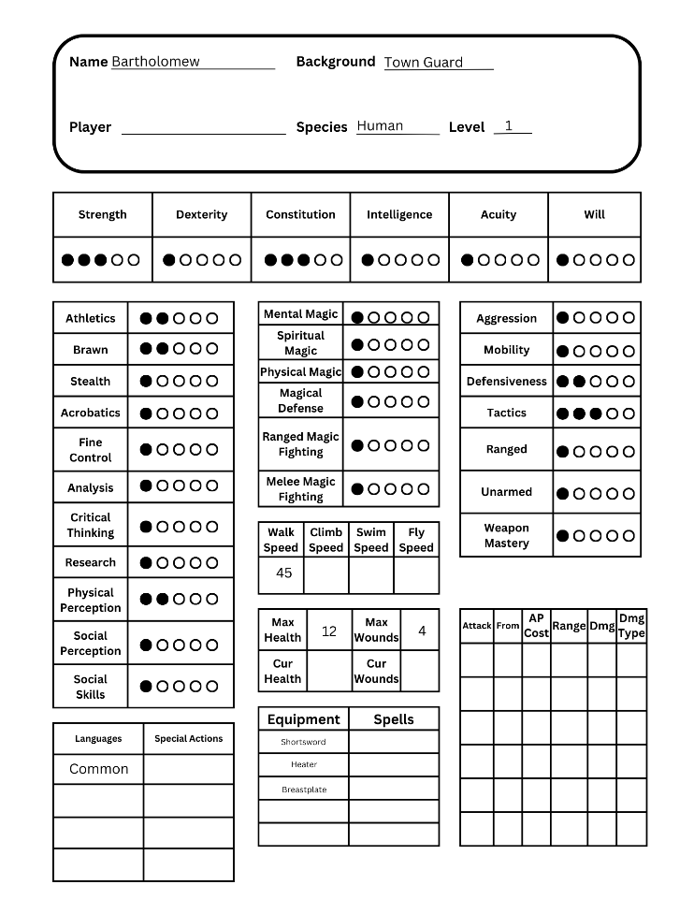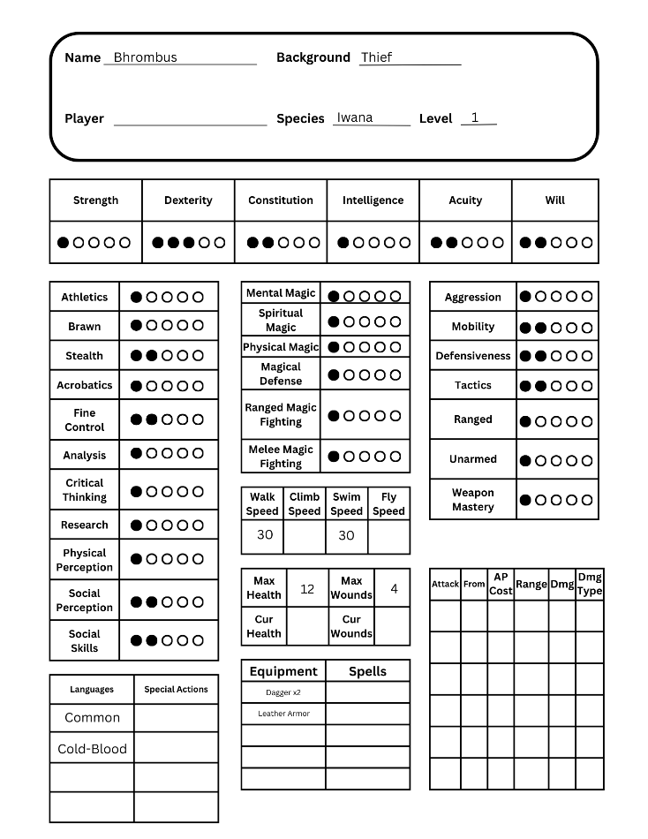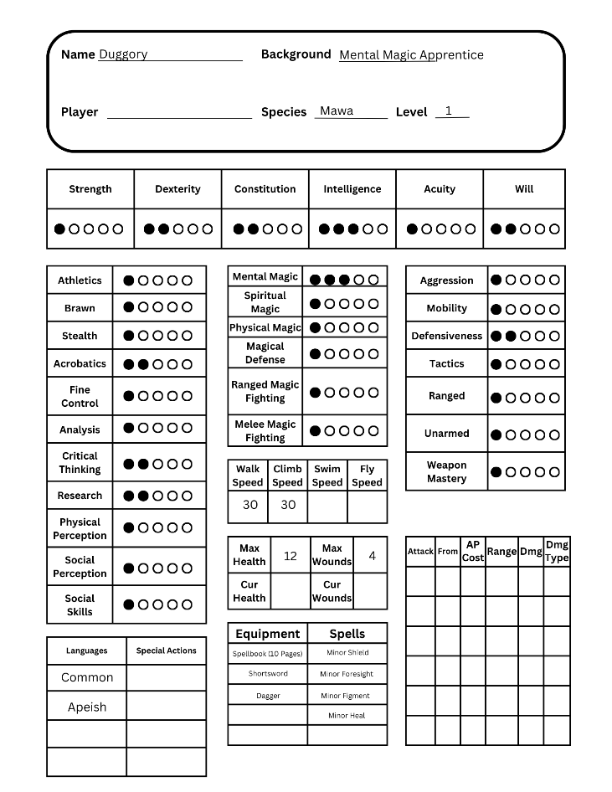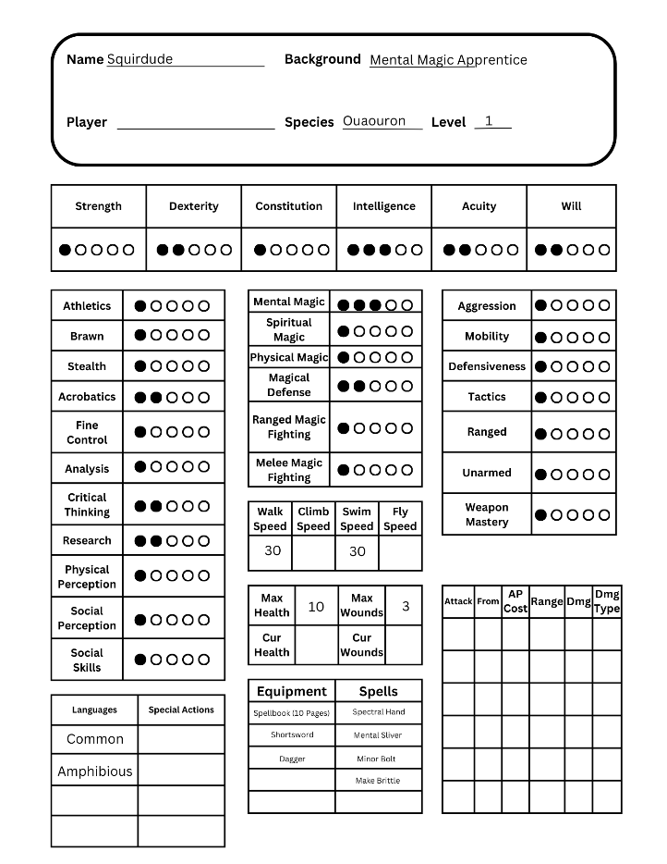

# Appendix F: Credits